Media Release

Phonak Lumity is now available for all ages and hearing loss levels

Lumity hearing aid technology extends to Audéo L-312, Naída L SP, and Sky L M and SP

Stäfa, Switzerland, February 21, 2024 – Phonak, a global leader in innovative hearing solutions, proudly announces the latest additions to its product lineup: Audéo L-312, Naída L-SP, and Sky L-M and SP. These hearing aids feature highly advanced Lumity technology, a breakthrough in addressing the primary concern of hearing aid users – improved speech understanding in noisy environments.

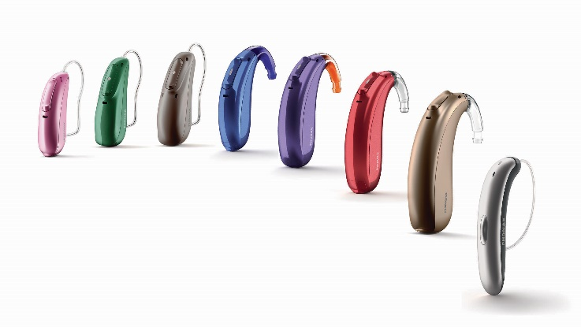
With these new additions, Phonak's Lumity technology offers a comprehensive solution for a wide range of hearing needs. Lumity not only addresses the core concerns of hearing aid wearers but also empowers them with innovative features, connectivity options, and personalized control through the myPhonak and myPhonak Junior app. Lumity, equipped with SmartSpeech Technology, has been proven to enhance speech understanding and reduce listening effort ^{1, 2, 3, 4, 5}*.

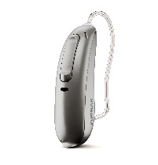
Audéo L-312: A New Form Factor for Enhanced Client Satisfaction
Audéo L-312 introduces a new replaceable battery option to meet the diverse needs of clients while featuring SmartSpeech Technology for improved speech understanding and reduced listening effort. Universal connectivity ensures users can stay connected to the world around them.

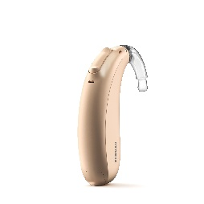
Naída L-SP: Super Power for Super Performance
The Super Power (SP) version of Naída is the most popular form factor. Designed to meet the needs of individuals with severe hearing loss, these Behind-The-Ear (BTE) hearing aids boast an IP68 rating, ensuring both durability and reliability. With remarkable performance, the Naída L-SP delivers unparalleled functionality for users seeking advanced hearing solutions.

When paired with Roger™ technology, Naída Lumity presents a formidable combination for better hearing in noisy environments and at a distance, boasting a 61% improvement in speech understanding in group conversations ⁶**. Functioning like a third ear, Roger microphones help people with hearing loss learn, work and socialize more easily by transmitting a speaker’s voice directly to the listener’s hearing aids. In fact, 90% of Roger users would recommend this dynamic yet powerful pairing to friends and family ⁷.

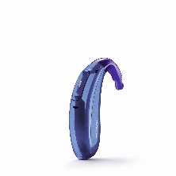
Sky L-M and SP: Empowering the Next Generation
Sky Lumity, now with the M form factor for infants and the most popular Super Power (SP) version, expands the Phonak Pediatric offering. Recognized with a 2023 Hearing Technology Innovator Award, Sky Lumity is designed for children and teenagers, prioritizing speech understanding in noisy classroom environments. Children who use Sky hearing aids in conjunction with Roger technology experience 34%⁸ better speech understanding compared to using hearing aids alone, granting them access to an additional 5,300 words per day ***.

The highly rated myPhonak Junior app, winner of the Hearing Technology Innovator 2023 award in the Mobile Apps for Hearing Devices category, seamlessly integrates with a broad selection of Phonak hearing aids. This dedicated pediatric app empowers children and allows parents to monitor wearing time, schedule remote consultations, and set parental controls.

These latest additions to the Phonak Lumity product range are available as of February 21, 2024.
For further information about Phonak and the broad Lumity offer, please visit www.phonak.com.

Source/Reference

- Appleton, J. (2020). AutoSense OS 4.0 - significantly less listening effort and preferred for speech intelligibility. Phonak Field Study News. https://www.phonak.com/evidence
- Latzel, M., & Hobi, S. (2022). ActiveVent™ Receiver provides benefit of open and closed acoustics for better speech understanding in noise and naturalness of own voice perception. Phonak Field Study News. https://www.phonak.com/evidence.
- Thibodeau L. M. (2020) Benefits in Speech Recognition in Noise with Remote Wireless Microphones in Group Settings. Journal of the American Academy of Audiology, 31(6), 404–411.
- Latzel, M., Lesimple, C., & Woodward, J. (2022). New implementation of directional beamforming configurations show improved speech understanding and reduced listening effort. Phonak Field Study News. https://www.phonak.com/evidence
- Latzel, M., Lesimple, C., & Woodward, J. (2023). Speech Enhancer significantly reduces listening effort and increases intelligibility for speech from a distance. Phonak Field Study News. https://www.phonak.com/evidence Thibodeau L. M. (2020). Benefits in Speech Recognition in Noise with Remote Wireless Microphones in Group Settings. Journal of the American Academy of Audiology, 31(6), 404–411
- Thibodeau L. M. (2020) Benefits in Speech Recognition in Noise with Remote Wireless Microphones in Group Settings. Journal of the American Academy of Audiology, 31(6), 404–411.
- Sonova proprietary research. (2019). Project ID #1299. Please contact marketinsight@phonak.com if you are interested in further information.
- Wolfe, J., Neumann, S., Schafer, E., Towler, W., Miller, S., Dunn, A., Jones, C., Nelson, J. (2021). Evaluation of a Dual Adaptive Remote Microphone System. Journal of Educational, Pediatric & (Re)Habilitative Audiology (JEPRA), Vol. 25, 2021-2027

* For adults with moderate to severe hearing loss
** In loud noise compared to hearing aids alone
*** Benitez-Barrera, C.R, Angley G.P., & Tharpe, A.M. (2018). Remote microphone system use at home: Impact on caregiver talk. Journal of Speech, Language and Hearing Research, Vol. 61, 399-409.

Media relations contacts:
Global
Florence Camenzind
Phone +41 58 928 33 25
Email florence.camenzind@sonova.com

U.S.
John Urbaniak
Phone +1 331 204 2799
Email john.urbaniak@sonova.com

– End –

About Phonak
life is on. Since 1947, Phonak has been dedicated to improving the quality of life for people with hearing loss. Seventy-five years later, our passion for creating life-changing hearing solutions that help people thrive physically, socially, and emotionally remains. By offering the industry’s broadest portfolio of hearing solutions, we are committed to creating a world where “life is on” for everyone. At Phonak, innovation is not limited to products. We work to change the conversations surrounding people with hearing loss. We do this by fighting the stigma of hearing aids and creating an understanding of how hearing is connected to the broader context of healthy living.

